Nicholas Menough

Final Project

SE-410 Software

Upper Iowa University

Triangle program Testing:

**7 Product Dimensions**

|  |  |
| --- | --- |
| User | The user will open the program on there windows 10 machine. The user will enter 3 integers and the program will tell them if this is a triangle or not. |
| Interface | The interface will be a GUI where it will open on windows 10 machine. The following chart shows the flow of the interface. |
| Action | The user uses their key board and mouse for this program. The user can enter in text or numbers. The user will then will click check. The user will check to see what they entered is a triangle or not. |
| Data | The data is provided by the user. This program can only tell what type of triangle it is or if its not a triangle. |
| Control | This program only works on a windows 10 machine. This has not been tested on any other operating machine. |
| Environment | User must have the program downloaded on a windows 10 machine. The User will then open the program on their desktop device. The user does not need internet to run this program. |
| Quality Attribute | The Program will need to be tested to make sure that the program meets the requirements set. There are no updates yet for this program to run on a mobile device or be a web application. |

**JUNIIT Testing:**

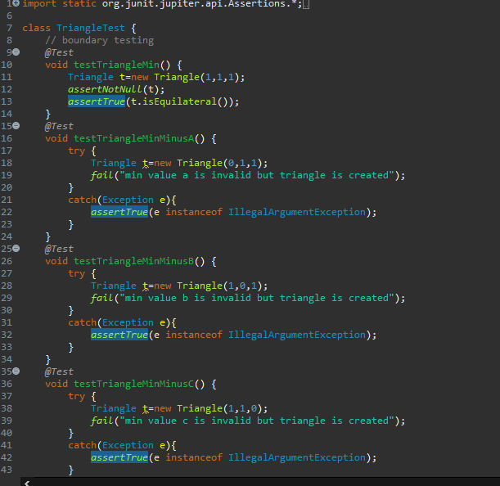

All Testing as Passed:

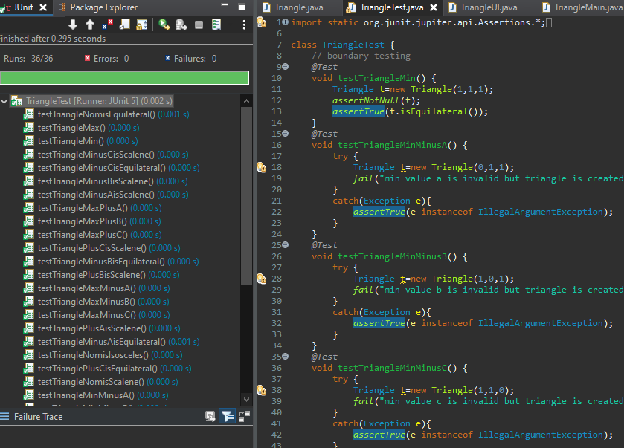

**Normal boundary and robust testing:**

|  |  |  |  |  |
| --- | --- | --- | --- | --- |
| Test Case | Test data | Test type | Expected Value | Test Results |
| 1 normal boundary | A:1  B:1  C:1 | Min | Equilateral | Equilateral |
| 2 normal boundary | A:0  B:1  C:1 | Min -a | Invalid | Invalid  Must be between 1-200 |
| 3 normal boundaries | A:1  B:0  C:1 | Min -b | Invalid | Invalid  Must be between 1-200 |
| 4 normal boundaries | A:1  B:1  C:0 | Min -c | Invalid | Invalid  Must be between 1-200 |
| 5 normal boundaries | A:2  B:2  C:1 | Min +a | Not a Triangle | Not a Triangle |
| 6 normal Boundary | A:1  B:2  C:1 | Min + b | Not a Triangle | Not a Triangle |
| 7 normal Boundary | A:1  B:1  C:2 | Min + b | Not a Triangle | Not a Triangle |
| 8 normal Boundary | A:200  B:200  C:200 | Max | Equilateral | Equilateral |
| 9 normal Boundary | A:201  B:200  C:200 | Max plus A | Triangle but invalid | Must be inclusive |
| 10 normal Boundary | A:200  B:201  C:200 | Max Plus B | Triangle but invalid | Must be inclusive |
| 11 normal Boundary | A:200  B:200  C:201 | Max Plus B | Triangle but invalid | Must be inclusive |
| 12 normal Boundary | A:199  B:200  C:200 | Max minus A | Isosceles | Isosceles |
| 13 normal Boundary | A:200  B:199  C:200 | Max minus B | Isosceles | Isosceles |
| 14 normal Boundary | A:200  B:200  C:199 | Max minus C | Isosceles | Isosceles |
| 15 normal Boundary | A:200  B:200  C:199 | Max minus C | Isosceles | Isosceles |
| 16 normal Boundary | A:1  B:10  C:12 | Nominal | Not a triangle | Not a triangle |
| 17 normal Boundary | A:10  B:10  C:10 | Is Equilateral Max - | Equilateral | Equilateral |
| 18 normal Boundary | A:9  B:10  C:10 | Is Not Equilateral Max - | Isosceles | Isosceles |
| 19 Robust Testing | A:10  B:9  C:10 | Is Not Equilateral Max - | Isosceles | Isosceles |
| 20 Robust Testing | A:10  B:10  C:9 | Is Not Equilateral Max - | Isosceles | Isosceles |
| 20 Robust Testing | A:10  B:11  C:10 | Is Not Equilateral Max + Min- | Isosceles | Isosceles |
| 21 Robust Testing | A:10  B:10  C:11 | Is Not Equilateral Max + Min- | Isosceles | Isosceles |
| 22 Robust Testing | A:5  B:5  C:8 | Nom min | Isosceles | Isosceles |
| 23 Robust Testing | A:4  B:5  C:8 | Max- | Scalene | Scalene |
| 24 Robust Testing | A:5  B:4  C:8 | Max- | Scalene | Scalene |
| 25 Robust Testing | A:5  B:5  C:7 | Max- | Isosceles | Isosceles |
| 26 Robust Testing | A:6  B:5  C:8 | Max- | Scalene | Scalene |
| 27 Robust Testing | A:6  B:5  C:8 | Max+ min- | Isosceles | Isosceles |
| 28 Robust Testing | A:29  B:36  C:44 | nom | Scalene | Scalene |
| 29 Robust Testing | A:29  B:35  C:44 | Max - | Scalene | Scalene |
| 30 Robust Testing | A:28  B:36  C:44 | Max- | Scalene | Scalene |
| 31 Robust Testing | A:29  B:35  C:43 | Max- | Scalene | Scalene |
| 32 Robust Testing | A:30  B:36  C:44 | Max + min- | Scalene | Scalene |
| 33 Robust Testing | A:29  B:37  C:44 | Max + min- | Scalene | Scalene |
| 34 Robust Testing | A:29  B:36  C:45 | Max + min- | Scalene | Scalene |

**Test Matrix:**

* White: means not tested
* Green: good to go
* Yellow: Done needs more testing
* Red: broken
* Gray: Not applicable doesn’t need testing

|  |  |  |  |  |  |  |  |  |  |
| --- | --- | --- | --- | --- | --- | --- | --- | --- | --- |
| Money Exchange | 1-200 | Looks/ feels | Message | Device Windows | Load time | Error handling | Boundary conditions | Load performance | Security |
| Convert to Isosceles |  |  |  |  |  |  |  |  |  |
| Convert to Scalene |  |  |  |  |  |  |  |  |  |
| Convert Eu |  |  |  |  |  |  |  |  |  |
| Convert Equilateral |  |  |  |  |  |  |  |  |  |
| Says not Not a Triangle |  |  |  |  |  |  |  |  |  |
| Sides >200 |  |  |  |  |  |  |  |  |  |

Mock Up A/B testing

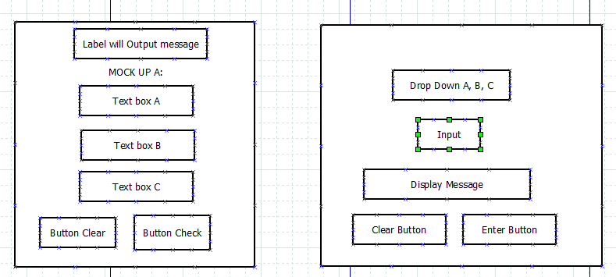

**Testing A/B:**

|  |  |
| --- | --- |
| Test A | Test B |
| User enters 29 for :A  User enters 35 for :B  User enters 44 for :C  User clicks Check Button  Output Label displays: Scalene | User select A and inputs 29 for A.  User clicks enter buttons  Display message says enter Side B  User enters 35  User clicks enter  Display message says enter Side B  User enter 44 for side C  User clicks enter button  Output Label displays: Scalene |
|  |  |
| Test A | Test B |
| User enters 29 for :A  User enters 29 for :B  User enters 44 for :C  User clicks Check Button  Output Label displays: Isosceles  User clicks the X button to close programs | User select A and inputs 29 for A.  User clicks enter buttons  Display message says enter Side B  User enters 29  User clicks enter  Display message says enter Side B  User enter 44 for side C  User clicks enter button  Output Label displays: Isosceles  User Clicks Okay |

**UI Testing**

|  |  |  |
| --- | --- | --- |
| Test cases | Function | Result |
| Test1 | Enter Side A | Pass |
| Test2 | Enter Side B | Pass |
| Test3 | Enter Side C | Pass |
| Test4 | Clear button | Pass |
| Test5 | Check Button | Pass |
| Test6 | X close button | Pass |
| Test 7 | Clear Button | Pass |
| Test 8 | Enter button | Pass |
| Test 9 | Input box’s | Pass |
| Test 10 | Display label | Pass |
| Test 11 | Message for the not a triangle | Pass |
| Test 12 | Message for Equilateral | Pass |
| Test 13 | Message for Isosceles | Pass |
| Test 14 | Message for Scalene | Pass |
| Test 15 | Message for not inclusive 200 | Pass |
| Test 21 | Page loading | Pass |

**User input Invalid Testing:**

|  |  |  |
| --- | --- | --- |
| **Test Case** | **Function** | **Output** |
| Test 1 | **Side A: Ten**  **Side B: 5**  **Side C: 5** | **Integers only** |
| Test 2 | **Side A:5**  **Side B: Ten**  **Side C: 5** | **Integers only** |
| Test 3 | **Side A:5**  **Side B: 5**  **Side C: Ten** | **Integers only** |
| Test 4 | **Side A:-1**  **Side B: 5**  **Side C: 5** | **Must be between 1-200:-1** |
| Test 5 | **Side A:5**  **Side B: -1**  **Side C: 5** | **Must be between 1-200:-1** |
| Test 4 | **Side A:5**  **Side B: 5**  **Side C: -1** | **Must be between 1-200:-1** |
| Test 4 | **Side A:-1**  **Side B: -1**  **Side C: -1** | **Must be between 1-200:-1** |
| Test 4 | **Side A: null**  **Side B: null**  **Side C: null** | **Invalid Entry** |
| Test 5 | **Enter a float 2.45 for sides** | **Integers only** |

**Use cases:**

User who is using this program at work wants to check to see if the sides for A, B, C are one of the three triangles.

|  |  |  |
| --- | --- | --- |
| Use Case | Scenario | Testing Results |
| User Enters 40,40,40 | Valid Entry | User see welcome screen on Input Side A, B, C . System displays message |
| User enter Ten instead of 10 for all three side | INVALID Entry | Invalid message appears and user must enter integers only |
| User enters 10,10,10 | Valid Entry | Message displays: Equilateral |
| User enters Ten,Ten, Ten | INVALID Entry | Invalid message appears and user must enter integers only |
| User enters 10,5,10 | Valid Entry | Message displays: Isosceles |
| User enters Ten,5, 10 | INVALID Entry | Invalid message appears and user must enter integers only |
| User enters 201,5, 5 | INVALID Entry | Invalid message appears and must be between 1…200 inclusive 201 |
| User enters 7,10,5 | Valid Entry | Message displays: Scalene |
| User enters 7,five, 10 | INVALID Entry | Invalid message appears and user must enter integers only |